# ABSTRACT

**Proposal Number:** CR24-A4-8072

**Proposal Title:** Advancing engineering design guidance for constructed salt marshes with high fidelity modeling and long-term monitoring

**Lead Principal Investigator:** Todd Steissberg, Environmental Laboratory, Engineer Research and Development Center, U.S. Army Corps of Engineers

**ESTCP Topic Area:** Retrospective Assessment of Coastal Installation Protection Infrastructure.

**Lead Organization:** Todd Steissberg, Environmental Laboratory, Engineer Research and Development Center, U.S. Army Corps of Engineers, 707 Fourth Street, Suite 100, Davis, California 95616, 530-219-7990, [Todd.E.Steissberg@usace.army.mil](mailto:Todd.E.Steissberg@usace.army.mil), Todd.E.Steissberg@erdc.dren.mil

**Objective:** The objective of this project is to test a novel modeling approach to quantify how well existing salt marshes increase coastal resilience to stressors like wave action and erosion both under current and projected future conditions. The team will use lessons learned from evaluation of existing sites to develop recommendations for an initial salt marsh design framework based on desired marsh performance. The specific technical objectives are to (1) validate and calibrate the innovative salt marsh design model to be completed in FY23 for one selected long-establish reference and one more recent restoration site, (2) evaluate wave attenuation and habitat performance at the paired sites under historic conditions, (3) evaluate wave attenuation and habitat performance at the paired sites under a range of potential future sea level rise scenarios, and (4) use lessons learned to develop initial recommendations for a framework linking modeling, field and lab research, monitoring, and design evolution.

**Technology Description:** The proposed technology is an innovative salt marsh model that dynamically couples hydrodynamics, waves, morphology, and vegetation growth/death. While other salt marsh models exist, none are capable of both spatially distributed simulations and directly coupling vegetation biomass lifecycles with salt marsh bottom accretion and compaction. The inclusion of these processes will support a better understanding of the relationships between specific marsh characteristics and performance objectives. The purpose of the model will be to (1) evaluate existing salt marsh habitat and wave attenuation performance under current and projected future scenarios at specific sites and (2) enable initial recommendations for a salt marsh design framework from the site evaluations. Success will be achieved if the model can reasonably reproduce existing marsh behavior, quantify marsh wave attenuation and habitat performance under multiple scenarios, and begin to reveal clear relationships between performance metrics and marsh characteristics. Overall success would be the development of a draft design framework that links modeling, field and lab research, and monitoring to inform salt marsh design for specific performance objectives.

**Expected Benefits:** The anticipated cost for this effort is $460K in year 1 and $245K in year 2, which sum to $705K for the total effort. The technology (model) to be tested under this project would improve how we currently design salt marsh restoration projects. Current practice focuses primarily on habitat creation and relies heavily on in-depth field knowledge. The model developed as part of this effort would improve understanding of the relationships between marsh site characteristics and specific performance metrics like percent wave attenuation. This improved understanding would feed into a framework that could provide and quantify the direct benefits to upland structures such as levees by reducing potential erosion. Additionally, this framework could eventually lead to more reliable salt marsh design and construction, resulting in reduced post-construction corrective costs. This framework could also help expand the use of salt marshes as reliable and sustainable wave attenuation structures, where appropriate, throughout coastal DoD installations. Since salt marshes provide a large range of benefits from flood reduction to recreation to habitat creation, their ROI is multi-faceted and long-lived.

# TECHNICAL SECTION

**1. Short Descriptive Title:** Advancing engineering design guidance for constructed salt marshes with high fidelity modeling and long-term monitoring

**2. ESTCP Topic Area:** Environmental Technology *(Retrospective Assessment of Coastal Installation Protection Infrastructure)*

**3. Lead Organization:** Todd Steissberg, Environmental Laboratory, Engineer Research and Development Center, U.S. Army Corps of Engineers, 707 Fourth Street, Suite 100, Davis, California 95616, 530-219-7990, [Todd.E.Steissberg@usace.army.mil](mailto:Todd.E.Steissberg@usace.army.mil), [Todd.E.Steissberg@erdc.dren.mil](mailto:Todd.E.Steissberg@erdc.dren.mil)

**4. Problem Statement:** The DoD is required to build and sustain natural infrastructure to meet multiple requirements including habitat, coastal protection, and flood reduction. Such nature-based features, if constructed correctly, have the potential to increase coastal resilience to a range of stressors like sea level rise. Successful design and construction of such infrastructure requires two elements: (1) solid engineering design and (2) in-depth field knowledge and construction considerations. Current design practices rely heavily on the latter, field knowledge (see Table 5), but lack clear engineering designs that link data and model-driven relationships with marsh design parameters with performance. Salt marshes are complex ecosystems that naturally change over time, making them difficult to model and design for specific performance objectives. Despite their documented capacity to attenuate waves, the engineering community does not consider salt marshes as coastal protection infrastructure because, up to this point, we lack a standardized method for predicting flood reduction benefits largely due to their complexity and natural variability. Process-based models that couple physical and biological/vegetation processes are needed to understand and predictably simulate the behavior of these complex natural systems. And while many high-fidelity salt marsh models do exist, they have been largely used to gain insight on how different environmental drivers like sea level rise, waves, and sediment delivery impact existing salt marsh habitats (Swanson et al. 2014, Best et al. 2018, Neederhoff et al. 2021, Willemsen et al. 2022). No efforts, to the author’s knowledge, are currently aimed at using such models to characterize the relationships between different salt marsh design parameters (e.g., starting marsh elevations) and performance metrics (e.g., mean daily wave attenuation). Additionally, while researchers and practitioners do collaborate to better understand and design salt marshes, such collaboration does not feed directly into the current design framework. The authors believe that design guidelines should incorporate a formal framework of how modeling, field and laboratory studies, design and construction, and monitoring tie together to inform and continually advance salt marsh design methods.

**5. Technology Demonstration:**

a. ***Technical Objective*:** This project proposes to use a combination of literature values; and existing data including NOAA buoy gage data, USGS elevation data, and data currently being collated and collected by the San Francisco Estuary Wetlands Regional Monitoring Program (WRMP) (see Table 4 for subset of marshes from Williams and Faber 2004) to (1) validate and calibrate the salt marsh design model we plan to complete in FY23 for 1-2 selected benchmark (natural) or reference (long-term restoration) sites and 2 more recent restoration sites, (2) evaluate wave attenuation and habitat performance at the sites under historic conditions, (3) evaluate wave attenuation and habitat performance at the sites under a range of potential future sea level rise scenarios, and (4) use lessons learned to develop initial recommendations for a framework linking modeling, field and lab research, monitoring, and design evolution.

**b. *Technical Description*:** The current state of the practice relies primarily on field-knowledge-based practical construction guidelines to design salt marshes. Additionally, the primary purpose of a majority constructed salt marshes is habitat creation. This effort proposes a novel approach to develop an initial framework by which we could incorporate data and model-driven engineering design methods into this process. The development of engineering design methods would facilitate the targeted design of salt marshes for specific performance objectives like wave attenuation by a certain percent. The authors feel that natural infrastructure has potential to provide significant benefits beyond habitat creation. Current design practices, however, prevent us from reliably quantifying such benefits based on marsh design.

**Theory**

Salt marshes are coastal intertidal wetland habitats that are flooded and drained by salt water brought in by the tides. The correct balance of sediment accretion, mean sea level, and water quality are necessary to support healthy salt marsh vegetation. There are five main groups of processes that define salt marsh behavior: (1) hydrodynamics, (2) wave input and internal propagation, (3) vegetation growth and death, (4) sediment accretion and erosion, and (5) water quality and chemical processes (Pomery and Wiegert 1981; Houwing et al. 2002). Feedback loops exist between these five processes. Sea level rise, for example, will impact plant survival, which will, in turn, impact sediment accretion, salt marsh bottom elevation, and wave attenuation capacity. The resulting bottom elevation will impact water levels in the marsh, controlling vegetation survival and subsequent marsh wave attenuation capacity. If marsh sediment accretion can keep pace with sea level rise (i.e., the marsh bottom elevation increases at the same rate as sea level rise), then the marsh can survive. Due to their dynamic nature and exposure to variable wave and hydrodynamic action, salt marshes also vary greatly spatially. Vegetation establishment patterns can also significantly impact salt marsh channel formation and flow paths (Temmerman et al. 2007; van Maanen et al. 2015; Best et al 2018; Schwartz et al. 2022). Given the documented significance of these relationships between vegetation, waves, hydrodynamics, and morphologic spatial distribution, it is important to model them in a spatially explicit manner.

Numerous models have been developed to quantify the complex interactions that occur within the hydrodynamics, morphology, and vegetation life cycle of a salt marsh. Two main categories of models currently exist in the field. The first category includes lumped, non-spatial models that usually run on an annual or seasonal time step and focus on long-term, high-level vegetation-morphology-still-water-level interactions (Morris 2007, Swanson et al 2013, Schile et al 2014). The second category includes spatially distributed, high-resolution models with varied time steps that can be as short as seconds, which focus on capturing the physical processes that exist in the hydrodynamics-vegetation-morphology interactions (Best et al. 2018, Nederhoff et al. 2021, Willemsen et al. 2022). While the first group of models are aimed at the bigger picture of “what will existing salt marshes look like in the future,” the second group of models explores the sensitivity of salt marsh habitats to different parameters such as waves, tides, vegetation density, etc.

Existing models have been used mainly to understand salt marsh dynamics and to evaluate existing salt marsh survival under a range of potential future sea level rise and sediment delivery scenarios. And while models like the one developed by Willemsen et al. 2022 do include morphology and vegetation dynamics, none explicitly link the two processes to simulate the feedback between bottom elevation and dead vegetation biomass accumulation. This effort proposes two contributions to the existing salt marsh modeling field, (1) to develop a spatially distributed model that builds on existing models to strengthen the link between morphology and vegetation lifecycle processes and (2) use that model to inform salt marsh design for specific performance objectives. For this effort, the model will focus on the first four processes, excluding water quality. While water quality processes are important, especially with respect to plant survival, it was concluded that they were the least significant of the processes in the potential San Francisco Bay sites to be analyzed. The team plans to add in water quality in the future once the other processes have been incorporated and validated.

**Functionality**

In order to understand how salt marshes evolve and perform over time, we need to reliably model their dynamics over time. This effort will leverage a salt marsh model that the authors’ team will complete in the second quarter of FY24. This model builds off and links four existing models, (1) the Deltares Delft 3D hydrodynamics model (<https://oss.deltares.nl/web/delft3d/about>), (2) the Deltares D-Waves model (<https://www.deltares.nl/en/software-and-data/products/delft3d-fm-suite/modules/d-waves>), (3) the Deltares NBSDynamics vegetation model (<https://github.com/Deltares/NBSDynamics>), and (4) the SEMIDEC (Sedimentation, Mineralization, and Decomposition) salt marsh model (Morris and Bowden 1986). For the hydrodynamics model, the team will leverage the Delft3D salt marsh model developed by Neederhoff et al. (2021), adding in the capability to model vegetation lifecycle processes with the NBSDynamics model; and to link marsh morphology with vegetation growth, death, and decay with the SEMIDEC model. The schematic in Figure 1 shows all the processes and feedback loops represented in the model. With this model, the team will be able to characterize and evaluate the relationships between different design parameters like initial salt marsh elevations, sediment supply, etc. and specific performance metrics like daily mean wave attenuation and habitat type distribution over a range of historic and potential future scenarios.

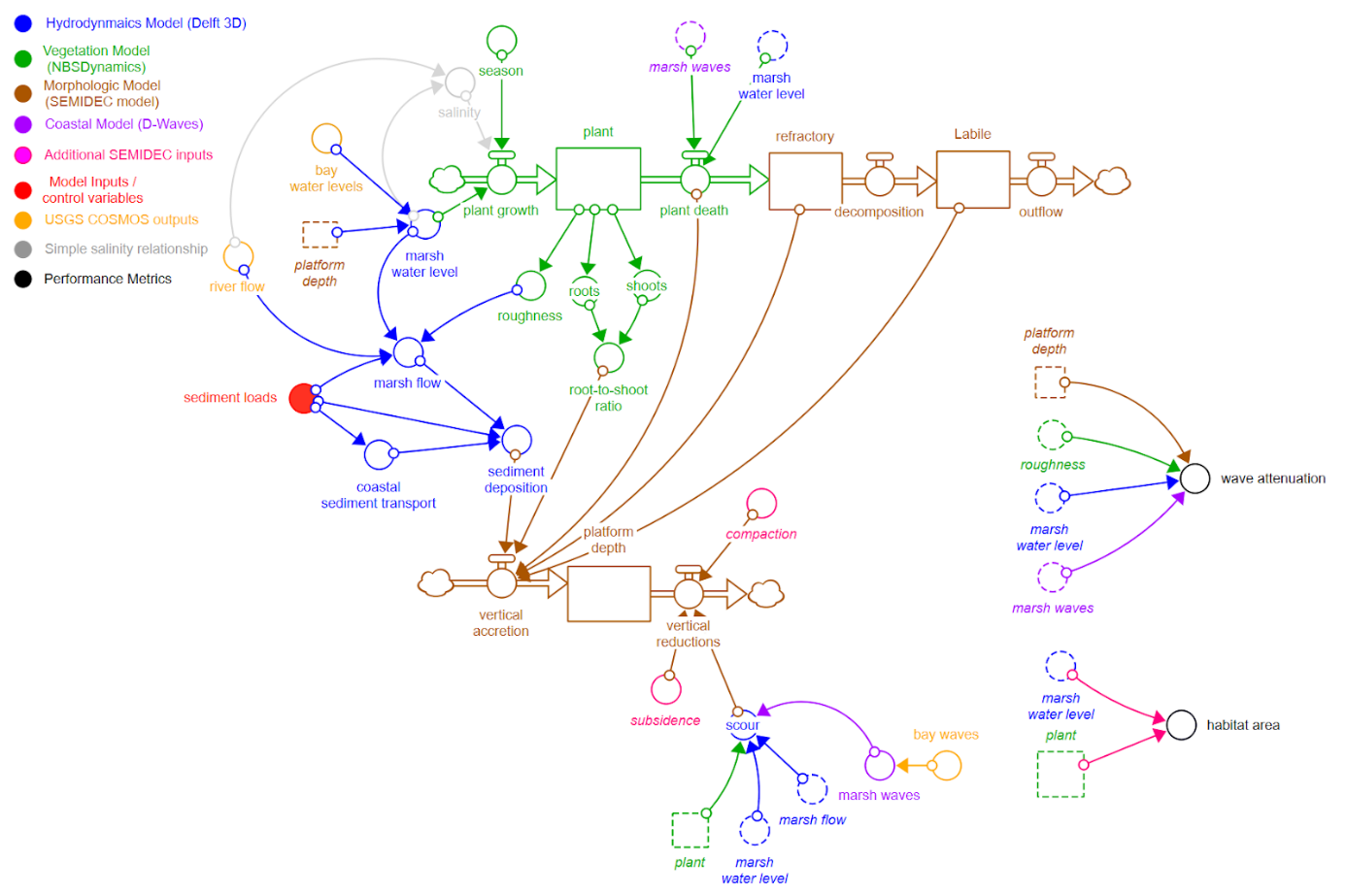

*Figure 1. Schematic of the four main salt marsh processes to be modeled and tested under this effort. The final performance metrics wave attenuation and habitat area are also included.*

**Validation and Calibration**

The salt marsh model will need to be calibrated and validated for the selected target benchmark/reference and restoration sites to ensure that it can predict all relevant marsh dynamics. The model will be run over the period of record with available input data and validation output data. The period of record will be split into calibration and validation periods. Input data will include:

* Input time series:
  + Water levels surrounding the marsh (hourly)
  + Waves entering the marsh (hourly)
* Critical input boundary conditions:
  + Initial marsh water levels
  + Initial morphology
  + Initial vegetation coverage
  + Initial marsh sediment concentration
  + Mean sediment concentrations surrounding the marsh

The team will manually calibrate the model to match the following output variables at the selected sites with observed data time series (as available):

* Water levels (hourly)
* Water velocities (hourly)
* Morphology (at least at start and end of calibration and validation periods)
* Marsh sediment concentrations / loading (ideally hourly, most likely will use constant average range based on site location)

The team will calibrate the model to the above output variables using those calibration parameters that are most sensitive and site specific. While the USACE team has some idea of what these parameters are, they will review the current literature and work with field experts from the San Francisco Estuary Institute (SFEI) to finalize the list of critical model calibration parameters. Based on the USACE team’s current understanding, the following calibration parameters will be targeted:

* Vegetation mortality rates
* Vegetation establishment behavior / success rates
* Above and below-ground biomass accretion rates

Depending on data availability, quality, and resolution, it may be necessary to collect some data measurements in the initial phase of this project.

**Operation**

The authors will use a combination of literature values; existing data sources like the developing WRMP database, NOAA buoy data, and USGS elevation data to validate and calibrate the salt marsh model for the paired restoration and benchmark/reference sites in the San Francisco Bay. The calibrated model will then be used to quantify the current and projected future marsh capacity to attenuate waves and to sustain target habitat types. The historical period of record for which relevant time series data are available will serve as the basis for all model simulation runs. Water levels from this period will be adjusted to simulate future potential sea level rise scenarios. The team will also use the model explore the sensitivity of marsh performance to starting mean bottom elevation. Finally, results will be analyzed and used to develop initial recommendations for a salt marsh engineering design framework. As part of these recommendations, the team will develop a framework linking modeling, monitoring, design guidelines, and practical construction guidelines.

**Innovation**

A salt marsh model that dynamically couples hydrodynamics, vegetation growth / death, and morphology dynamics does not currently exist and is an innovation in the ecological engineering field. Additionally, no models, to the authors’ knowledge, have been applied to directly evaluate salt marsh performance relative to specific performance metrics, nor to investigate relationships between marsh design parameters and performance metrics. This effort proposes to both evaluate existing marsh performance and to begin to explore how design parameters impact salt marsh performance over time and under potential future climate scenarios. The knowledge gained from this project would greatly improve our ability to (1) quantify salt marsh benefits and (2) design salt marshes for specific performance metrics, allowing engineers and planners to compare their benefits with analogous grey infrastructure and making salt marshes more defensible investments. While this effort is focused on salt marshes, the same modeling framework could be applied to other nature-based features (NBFs) to standardize their design and quantify their benefits.

**c. *Technology Maturity*:** The salt marsh model to be used in the proposed effort is currently being developed and will go through an initial validation and calibration for a test site in San Pablo Bay projected to be completed by the second quarter of FY24. This FY23/FY24 work is being funded through the ACTIONS (Anticipating Threats in Natural Systems) Program (see ***e. Related Efforts).*** This model also builds off an existing hydrodynamic model developed by Neederhoff et al (2021). Given that the team will not be building the base hydrodynamic model from scratch, we are confident that it will be ready for use for this effort by the start of this effort in April 2024.

**d. *Technical Approach*:**

**Project Phases and Tasks**

There will be five main phases to the proposed effort, (I) site selection and calibration parameter identification, (II) model calibration and validation for selected site, (III) model simulation, (IV) output compilation analysis, and (V) reporting and technology transfer.

Phase I – Site Selection and Identification of Key Calibration Parameters

The team has already selected one recent restoration site (Dotson Family Marsh) and one benchmark, natural, marsh site (Giant Marsh) in the San Francisco Bay. These paired marshes were chosen based on Task (1) will be to work with Navy and SFEI experts to select a second existing, planned, or potential restoration site. Selecting an existing marsh restoration would provide greater model validation while selecting a planned marsh site could test the model technology application, supporting greater technical transfer. Identifying a site with high potential for providing benefits to a DoD installation would allow for exploration and optimization of salt marsh design. We will also determine if a second reference site is necessary, or if the Giant Marsh site is an acceptable analog for the second selected site. (2) The USACE team will also consult SFEI and Navy experts to determine key calibration parameters (e.g., vegetation biomass accretion rates, vegetation mortality rates, etc.) on which to focus. (3) Once key calibration parameters are identified, the USACE team will work with SFEI and Navy experts to find relevant data and literature values for the critical model parameters defined in Task (1) for the sites of interest.

Phase II – Model Calibration and Validation

After all marsh sites are selected and necessary data obtained, the team will begin task (4), using the available data and literature values to calibrate and validate the salt marsh model for existing marsh sites (from Task 1). Goodness-of-fit metrics including the Root mean square error (RMSE) will be used to measure how well the model reproduces critical marsh behavior over time including water levels, water velocities, morphology, and vegetation coverage.

Phase III – Model Simulation

Once the model is calibrated adequately for the sites of interest, the next task (5) will use the model to simulate and evaluate the performance of wave attenuation (mean daily attenuation) and habitat creation (area of mudflats, low marsh, and high marsh) of the benchmark / reference and restoration sites over the historic period of record. The benchmark site(s) will serve as our best representation of natural marshes in dynamic equilibrium (e.g., stable sediment accretion rates, vegetation growth / death, etc.). The dynamics experienced at these analog sites will inform what equilibrium should look like at the restoration sites. (6) The model will be used to evaluate the projected future wave attenuation and habitat creation performance of all sites. Future sea level scenarios will be simulated by adjusting water levels surrounding the marsh of the historic period. The team will also explore how varying starting marsh elevation would impact performance. If time and computing power allow, the team may also include scenarios of varying sediment loading.

Phase IV – Output Compilation and Analysis

Task (7) will be to compile and analyze model outputs, looking for potential relationships between marsh design parameters and their performance. If significant relationships exist, the team will analyze and evaluate their relevance to salt marsh design. If the second restoration site selected is either a planned or potential site (i.e., not an existing marsh site), Task (8) will use the relationships identified in (7) to inform marsh design for the site. The resulting marsh design will be run through all historic and future scenarios to test its potential performance over time.

Phase V – Reporting and Technology Transfer

Task (9) will use the design relationships developed in step (7) to inform recommendations for a general framework to link modeling, field and laboratory studies, monitoring, design, and construction of salt marshes. Performance objectives are described in detail in Table 2 below. (10) The team will document findings in a Final ESTCP Report and one peer-reviewed journal. (11) The team will develop and present a poster, during each active year, at the SERDP and ESTCP symposium in the DC Area. (12) The team will develop a technology transfer strategy based on the level of recommendations for design framework updates.

*Table 1. Main project phases and tasks organized by the technical objective they support.*

|  |  |  |  |
| --- | --- | --- | --- |
| **Project Phase** | **Task #** | **Task Description** | **Technical Objective Supported** |
| Site Selection and Key Calibration Parameters | 1 | Review and select a second restoration site (and benchmark / reference site if needed) through conversation with Navy experts. | Identify all study sites and key calibration parameters |
| 2 | Identify key calibration parameters and corresponding data |
| 3 | Identify values for key calibration parameters with Navy and SFEI experts |
| Calibration and Validation | 4 | Use the available data and literature values to calibrate and validate the salt marsh model for the selected sites. | Validate and calibrate the salt marsh design model for the selected site(s). |
| Model Simulation | 5 | The model will be used to simulate and evaluate the performance of wave attenuation (mean daily attenuation) and habitat creation (area of mudflats, low marsh, and high marsh) of the selected existing sites over the historical period of record. | Evaluate current salt marsh performance. |
| 6 | The model will be used to evaluate the wave attenuation and habitat creation performance of the selected existing sites under potential sea level rise scenarios. | Evaluate marsh performance under a range of potential future sea level rise scenarios. |
| Output Compilation and Analysis | 7 | The results of modeling will be analyzed to characterize any observed relationships between marsh design parameters and their performance. | Use lessons learned to develop initial engineering design recommendations including a framework to link modeling, field and lab research, monitoring, and design evolution. |
| 8 | If the second restoration site selected is either a planned or potential site (i.e., not an existing marsh site), use the relationships identified in Task 8 to inform marsh design for site. The resulting design will be run through all scenarios from Tasks 6 and 7. |
| Reporting and Technology Transfer | 9 | Recommendations will be made for a general framework to link modeling, field and laboratory studies, monitoring, design, and construction of salt marshes. |
| 10 | The team will document findings in a Final ESTCP Report and one peer-reviewed journal. |
| 11 | Poster presentations at annual SERDP and ESTCP symposiums |
| 12 | Development and execution of technology transfer |

**Required Site Characteristics**

The team has focused this study to the San Francisco Bay due to the unique presence of relevant historic and project future water level and wave traces. These traces will serve as boundary conditions for the salt marsh model to be used in this study. Given this geographic scope, the Dotson Family (recent restoration) and Giant Marsh (adjacent natural, benchmark) sites were identified as marsh sites for this study. Located in the San Pablo Bay within San Francisco Bay, both sites have sufficient water level, vegetation, and morphology data needed for calibration (see Table 2). They are also located on the southeastern coast of San Pablo Bay, which is especially vulnerable to west-to-east wave action entering the San Francisco Bay from the ocean, making them excellent sites to measure wave attenuation benefits. 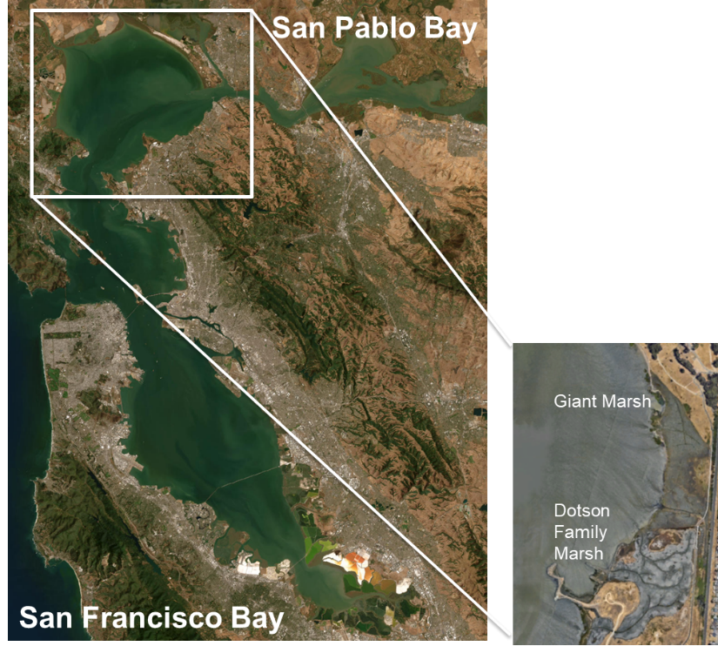

*Figure 2. Location of selected Dotson Family (recent restoration) and Giant (natural, benchmark) Marshes in San Pablo Bay.*

Additionally, three potential sites (Mare Island, Treasure Island, and Alameda) sites have been identified for a second study site based on preliminary research and discussions with the San Francisco Estuary Institute (SFEI) and Navy experts Scott Mauro and Mark Patterson. The Dotson Family marsh restoration was constructed by the East Bay Regional Park District (EBRPD) in 2014 and is about 150 acres. Detailed annual elevation data and vegetation surveys are available for the Dotson Family marsh. This proposal team has no relation to any of the marsh sites.

As part of the initial Phase I (site selection), the team will evaluate and rank potential sites for a second marsh site based on the following elements:

* Site benefits potential
  + Situated in an area that experiences waves, where a marsh could potentially attenuate waves.
  + Restoration marsh designed for habitat creation if constructed, or currently provided habitat if natural.
  + Comparable benchmark (natural) or reference (long-term restoration) site nearby or under similar conditions within the San Francisco Bay.
  + Relevancy to nearby DoD installations
* Data / literature value availability
  + Salt marsh output parameters
    - Site morphology data over time (e.g., annual elevation rasters)
    - Vegetation coverage over time (e.g., annual vegetation surveys)
    - Daily water levels (e.g., nearby hourly buoy data)
    - Daily water velocities (e.g., in-situ hourly flow gages, hourly wave recorders)
    - Mean sediment loading (e.g., seasonal turbidity tests on marsh)
  + Salt marsh calibration parameters (to be finalized under task 1)
    - Vegetation mortality rates
    - Vegetation establishment behavior / success rates
    - Above and below-ground biomass accretion rates

**Experimental Design / Scope**

* Hypotheses:
  + The model to be used in this effort can reasonably (RMSE < 0.5) simulate salt marsh hydrodynamic, vegetation, and morphologic behavior over time.
  + Predictable relationships exist between salt marsh characteristics and inputs, and performance metrics like wave attenuation.
  + The model can reliably capture these relationships between salt marsh characteristics and performance metrics.
  + For existing and planned marsh sites, the model can be used to estimate salt marsh wave attenuation and habitat performance over time.
  + If a potential marsh site is selected, the model can be used to develop preliminary salt marsh designs based on wave attenuation and habitat performance objectives.
* Independent variables of interest:
  + Physical marsh characteristics
    - Initial bottom elevation / morphology
  + Marsh inputs (time series)
    - Still water levels
    - Wave inputs
    - Sediment loadings
* Dependent variables of interest (time series):
  + Vegetation coverage
  + Inland waves
  + Equilibrium sediment accretion rate
* Experimental treatments (independent variables to be perturbed):
  + Marsh Inputs
    - Historical water levels
    - Projected high, medium, and low sea level rise scenarios
    - Starting mean bottom elevation (existing, low, and high scenarios)
    - *Sediment loadings (existing, low, and high scenarios) (if computing power and time allow)*
* Model simulations
  + Historical period runs (for restored and benchmark/reference sites): 2 to 3 scenarios
  + Future scenario runs (for restored and benchmark/reference sites):
    - 2-3 marsh sites x (2 water level scenario) x (3 bottom elevation scenarios) x *(3 sediment loading scenarios)* = 12 to *54* scenarios
* Marsh Design (if potential marsh site selected)
  + Leverage relationships between marsh design parameters (i.e., starting bottom elevation) and wave attenuation / habitat performance to design marsh in potential site.
  + Run designed marsh through all 6-18 historical and 18-54 future scenarios.
* Experimental Controls: The benchmark/reference marsh site performance under historical conditions will serve as the baseline for this experiment. We will assume that long-established and/or natural marshes have reached an equilibrium state with respect to sediment accretion and vegetation coverage under current conditions. Therefore, the benchmark/reference site should exhibit optimal performance for that region and marsh type.

**Assumptions**

* All data gaps can be filled with literature values
* Successful model validation and calibration will not require major changes to the model itself. If major model changes are required, Phase II (model calibration and validation) may require more effort than anticipated.
* Technical transfer can primarily be done virtually. The budgeted 51K for travel is intended for an initial kickoff meeting near the San Francisco Bay area and three working meetings at Deltares (developers of the Delft3D software with which the salt marsh model is built) in Delft, Netherlands.

**Data Analysis:** The team has chosen the Dotson Family Marsh (recent restoration) and Giant Marsh (natural, benchmark marsh) as study sites. As part of the initial Phase I (site selection), the team will coordinate with Navy and SFEI experts to select a second marsh restoration site and potentially a second benchmark/reference site if needed. This second site could be an existing, planned, or potential site. The team will evaluate the completeness and applicability of data for all potential sites as well as their relevance to DoD installations. This evaluation will include inspecting the data visually in time series plots and tables and comparing them with literature values. Once all restoration sites are finalized, the team will calibrate and validate the model with the goal of achieving a RMSE < 0.5 for marsh water levels, water velocities, bottom elevation, sediment concentrations, and vegetation coverage. After calibration, the model will be run under current and future scenarios. Model outputs will be used to calculate habitat area and mean wave attenuation metrics and success criteria as defined in Table 2. Table 2 summarizes the performance objectives, the metrics used to quantify these objectives, the data required to calculate these metrics, and success criteria used to measure how well objectives were met at a specific marsh site. Table 2. Performance objectives, metrics, data requirements, and success criteria for evaluating success of the proposed effort.

|  |  |  |  |
| --- | --- | --- | --- |
| **Performance Objective** | **Metric** | **Data Requirements** | **Success Criteria (subject to change based on site)** |
| **Quantitative Performance Objectives** | | | |
| Model calibration and validation | Goodness-of-fit of the model for salt marsh site selected | * Vegetation cover data * Daily water level data * Daily water velocity data * Sediment loadings / concentrations * Salt marsh elevation data * Vegetation mortality rates * Vegetation establishment rates * Biomass accretion rates | * Root mean square error < 0.5 |
| Create salt marsh habitat | Area of:   * high marsh habitat * low marsh habitat * mudflat habitat | * Vegetation cover data * Daily water level data * Daily water velocity data * Salt marsh elevation measurements | * (current habitat area achieved) / (habitat area goal) > 0.7 * (projected future habitat area achieved) / (habitat area goal) > 0.5 |
| Wave Attenuation | * Daily mean wave height attenuation | * Hourly water level data at bay and shore side of marsh * Hourly wave data at bay and shore side of marsh | * (mean historical wave height at shore side) /(mean historical wave height on bayside) < 0.8 * (mean projected wave height at shore side) / (mean projected wave height on bayside) < 0.6 |
| IDing of relationships between marsh characteristic and performance metrics | Correlation coefficient | * Dependent on trends identified through simulation | * Correlation coefficient > 0.5 |
| **Qualitative Performance Objectives** | | | |
| Technology transfer effectiveness | Successful communication of lessons learned and implications for marsh design | Feedback from audiences | Interest in pursuing future efforts to update formal salt marsh design methods and framework for DoD. |

**e. *Technical Risks:***

**Potential Issues / Technical Risks**

We assume that significant relationships can be identified between marsh characteristics and performance objectives. If this assumption is not true, we would not be able to produce design recommendations based on such relationships. With respect to scaling-up, there is also a risk that lessons learned from the San Francisco Bay sites do not translate to other regions in the US.

**Risk Management Plan**

* Careful site selection: The required sites will need sufficient data with the capacity to provide both habitat and wave attenuation benefits.
* Careful scenario selection: The team will perform an in-depth literature review and consult experts in the field to choose simulation scenarios (e.g., sea level rise scenarios, salt marsh starting elevations) that are based on the latest science, and that are most likely to demonstrate significant differences in performance.
* Long-term strategy: there will inevitably be regional differences in salt marsh behavior and performance capability. To scale this technology to all relevant coastal DoD installations, additional pilots would be required in future years across the main coastal US regions.

**f. *Related Efforts*:** The proposed effort would build off the products developed from current work under the ACTIONS (Anticipating Threats in Natural Systems) Program funding. ACTIONS is a Congressional Interest project whose purpose is to characterize environmental changes on military installations due to rising sea levels, increasing salinity, and increasing frequency and magnitude of extreme coastal events.

**6. Expected DoD Benefit:** The proposed technology is aimed at developing a framework by which salt marshes can be designed for specific objectives like wave attenuation and habitat creation. This framework could provide and quantify the direct benefits to upland structures such as levees by reducing potential erosion. Additionally, this framework could eventually lead to more reliable salt marsh design and construction, resulting in less post construction corrective costs. This framework could also help expand the use of salt marshes as reliable and sustainable wave attenuation structures where appropriate throughout coastal DoD installments. Given that salt marshes can provide a large range of benefits from flood reduction to recreation to habitat creation, their ROI will be multi-faceted and long-lived. Natural infrastructure like salt marshes, if designed and constructed properly, should require very little maintenance once they are established after installation and initial maintenance/monitoring as opposed to traditional gray infrastructure like levees and dikes, which require significant O&M over their design life. While salt marshes may shift and evolve in response to sea-level rise over time, their life span is on the order of hundreds of years versus current gray infrastructure alternatives, whose design lives are generally between 25-50 years and are static with respect to sea-level rise. Coupling salt marshes with grey infrastructure like levees and dikes could help reduce wave action reaching these structures, thus reducing their O&M costs, and increasing their useful life. If we can reliably design salt marshes to meet specific performance goals, they offer a more sustainable alternative (or complement) to traditional grey infrastructure, continuing to produce benefits long after the grey infrastructure crumbles.

**7. Schedule of Milestones:** Table 3 provides a schedule with all expected milestones and deliverables for the proposed effort. The salt marsh model to be used in this effort is projected to be completed by the end of FY 2023.

*Table 3. Project Gantt chart schedule. Q1 = Jan-Mar, Q2 = Apr-Jun, Q3=Jul-Sep, Q4=Oct-Dec. Assumed project start March 1, 2024. 2026 added as a no-cost contingency year based on the proposal guidelines.*

| **Task / Milestone** | **2024** | | | **2025** | | | | **2026 (contingency)** |
| --- | --- | --- | --- | --- | --- | --- | --- | --- |
|  | **Q2** | **Q3** | **Q4** | **Q1** | **Q2** | **Q3** | **Q4** |  |
| Identify second marsh site to evaluate in study and all necessary data |  |  |  |  |  |  |  |  |
| Collect any additional necessary data (e.g., wave transects) |  |  |  |  |  |  |  |  |
| **Milestone:** Calibrate and validate model for selected restoration and benchmark/reference sites  **Deliverable:** Calibrated models for existing sites. Model quality evaluated based on their goodness-of-fit statistics |  |  |  |  |  |  |  |  |
| Run calibrated models through historic and sea level rise adjusted periods of record for existing sites. |  |  |  |  |  |  |  |  |
| **Deliverable:** Poster for FY25 ESTCP Symposium |  |  |  |  |  |  |  |  |
| Compute existing site performance metrics (see Table 2) under historic and potential future conditions |  |  |  |  |  |  |  |  |
| Analyze results to evaluate and identify relationships between design parameters and site performance. |  |  |  |  |  |  |  |  |
| If potential marsh site selected, use identified relationships between design parameters and site performance to design marsh and run through all historic and future scenarios in the model. |  |  |  |  |  |  |  |  |
| **Deliverable:** Publish recommendations for incorporating modeling, field and lab studies, monitoring, design, and field knowledge into the planning and construction of salt marshes for specific objectives. |  |  |  |  |  |  |  |  |
| Technology transfer. |  |  |  |  |  |  |  |  |
| **Deliverable:** Submit first draft of Final Report for ESTCP (Oct 17, 2025) |  |  |  |  |  |  |  |  |
| **Deliverable:** Submit final draft of Final Report for ESTCP (Dec 19, 2025) |  |  |  |  |  |  |  |  |
| **Deliverable:** Publish one peer-reviewed journal article |  |  |  |  |  |  |  |  |

**8. Technology Transition:**  The salt marsh design framework produced from this effort is meant to serve as a blueprint for developing analogous frameworks across diverse coastal sites including DoD installations. Therefore, the transition of this salt marsh engineering design approach hinges on the effective transfer of the information provided in the design framework. The audience for this framework will be DoD installations, USACE planners, consultants, and potentially regulators. The team will directly communicate their findings and recommendations with each of these groups through use of fact sheets, webinars, and technology briefings as appropriate. One critical part of technology transfer will be to clearly identify specific users within DoD. We will use our cross-agency network to identify and meet with key users to determine if (1) the salt marsh design framework is relevant to their work and community and (2) if yes, what mode of technology transfer would be most useful for their community. The team would then cater their mode of communication based on this feedback. The team will reach the scientific community by presenting the effort’s findings at one relevant conference per year and by publishing one peer-reviewed journal article. Target initial users would be DoD installations on the east coast, where the design framework could be tested in a different regional context. Framework adaptation for a given region would likely take 2 to 4 years. Therefore, the overall time until full dissemination would rely on the available data and funding timing for each area of research.

**9. Disposition of Equipment:** N/A

**10. Performers:**

* Todd Steissberg, US Army Corps of Engineers, ERDC-EL (Principal Investigator)
* Matt Smith, US Army Corps of Engineers, IWR (modeler)

**11. ESTCP Review Comments:**

The team received the following feedback:

*“Develop more thorough technology transfer approach. Consider the development of additional Technology Transfer Tools in the form of fact sheets, webinars, technology briefings, and specifications/evaluation criteria.”*

In response to this feedback, the team has added more detail to the technology transfer approach in the **Technology Transition** section. We will focus on identifying key users through DoD, meeting with them to introduce the model and design framework, gage their interest, and ask them what resources and modes of communication would be most useful to them and their community. The team would then develop the appropriate fact sheets, webinars, demonstrations based on this initial feedback.

*“Please scale your project scope and budget to include a second marsh site in California or the east coast with minimal modification to your project framework.”*

*“Contact Scott Mauro (scott.mauro@navy.mil) at the Naval Facilities Engineering Systems Command (NAVFAC) for assistance with secondary site selection and corresponding budget adjustments.”*

The team has had initial conversations with both Scott Mauro and Mark Patterson about siting a second site. We have included coordination with them on a second site selection in the proposed effort scope and budget.

*“Include a statement within the proposal that a project poster will be presented, during each active year, at the SERDP and ESTCP symposium. Be sure to recognize this cost within relevant cost tables.”*

We have added the development and presentation of a project poster for each active year of the project into the project scope and budget.

**12. Acronym List:**

ACTIONS: Anticipating Threats in Natural Systems

SFEI: San Francisco Estuary Institute

WRMP: (San Francisco Estuary) Wetlands Regional Monitoring Program

OSU: Oregon State University

# COST SECTION

**TOTAL COST TABLE:**



**OREGON STATE UNIVERSITY (OSU) COST TABLE (NOTE: all funds will be sent to OSU in year 1, but expended as detailed in the table below):**



**1. Labor Costs:**

|  |  |  |  |  |  |
| --- | --- | --- | --- | --- | --- |
| **Team Member** | **Organization** | **Role** | **Labor Rate ($/hr)** | **Units (labor hours)** | **Total Labor Cost ($)** |
| Todd Steissberg | USACE | Principal Investigator | $219 / hr | 864 hours | $189,130 |
| Matt Smith | USACE | Modeler | $162 / hr | 1,132 hours | $183,107 |
|  |  |  |  | **TOTAL LABOR** | **$356,475** |

**2. Indirect Charge #1:** N/A

**3. Indirect Charge #2:** The funding sent to SFEI and Deltares via contract will be subject to departmental and G&A burdens. The departmental burden rate is 29% and the G&A burden rate is 11% for Army work, summing to a total burden rate of 40%. Therefore, the total cost of burdens is 0.4 x $194,960 = **$77,984.** And the totalcost for outgoing funds with burdens is $194,960 + $77,984 = **$272,944**.

**4. Major Equipment:** N/A – will leverage existing equipment if measurements are needed.

**5. Materials, Supplies and Consumables:** N/A

**6. Subcontracts and Government Partners:** Three sub-contractors will be used to support this effort. The San Francisco Estuary Institute (SFEI) will directly support Phase I of the projects. The total estimated SFEI contract will be **$30,000**. The USACE team will consult SFEI to determine critical calibration parameters and to identify a second marsh site and corresponding data. Deltares will directly support the model simulations (Phases VI and VII). Deltares is the software developer of the hydrodynamic (Delft3D), waves (Waves-D), and vegetation (NBSDynamics) models upon which the salt marsh model discussed in this proposal is based. The total estimated Deltares contract will be **$50,000**. The team will also work with a postdoctoral researcher at Oregon State University (OSU) to support model development and calibration, and perform model scenario runs (**$99,960**) (we have added this support to ensure we have sufficient modelers and computer power for the additional marsh site(s)). An additional cost sheet with a detailed cost breakdown is provided for the OSU support.

The team will also consult Navy experts in Phase I of this effort to select a second study site, and to identify key calibration parameters and their sources (**$15,000**). This support will include attendance of the initial kickoff meeting in the San Francisco area as well as searching for and providing relevant data and literature for the selected marsh site.

The total unburdened amount going to subcontracts and government partners is:

$30,000 (SFEI) + $50,000 (Deltares) + $99,960 (OSU) + $15,000 (Navy) = **$194,960**

**7. Travel Costs:** Travel costs only include those travel costs for the main USACE team (Todd Steissberg and Matt Smith). Travel for federal partners and subcontractors is included in the costs laid out in the previous section. The USACE modeler (Matt Smith) is based in the Washington DC area, and will not require travel funds to attend ESTCP meetings. This effort will include 4 trips, including 1 to San Francisco Bay area and 4 to Deltares in Delft, Netherlands:

* Initial kickoff meeting with the main output to select second site and determine critical calibration parameters with Navy and SFEI experts:
  + $3,500 x 3 travelers= $10,500
* Modeling and analysis meetings (Deltares in Delft, Netherlands):
  + Trip #1 (Review initial models for existing sites): $5,000 x 2 travelers = $10,000
  + Trip #2 (Discuss model scenario runs): $5,000 x 2 travelers = $10,000
  + Trip #3 (Model results analysis): $5,000 x 2 travelers = $10,000
  + Trip #3 (Output analysis / writing): $5,000 x 2 travelers = $10,000
* **TOTAL:** $10,500 + $10,000 + $10,000 + $10,000 + $10,000 = **$50,500**

**8. Publication and Report Costs:** The team plans to produce one peer-reviewed journal article from this effort. We estimate publication fees and clerical preparation to cost $5000.

**9. Fixed Fee:** N/A

**Cost by Task Summary Table:**

*Table 4. Overall cost breakdown by task. Year 3 is included as a no-cost contingency year as requested in the proposal guidelines. Task costs include labor, travel, and equipment.*

# 

|  |  |  |  |  |  |
| --- | --- | --- | --- | --- | --- |
| **Task #** | **Descriptive Task Name** | **Year 1 (3/1/24 - 1/31/25)** | **Year 2 (2/1/25 - 1/31/26)** | **Year 3 (2/1/26 - 1/31/27)** | **Total** |
| 1 | Consult SFEI and Navy experts to select 2nd site. *Includes kickoff meeting in San Francisco* | $ 71,220.63 | $ - | $ - | $ 71,220.63 |
| 2 | Determine key calibration parameters and corresponding data with SFEI and Navy experts | $ 29,682.16 | $ - | $ - | $ 29,682.16 |
| 3 | Identify values for key calibration parameters with Navy and SFEI experts | $ 23,591.68 | $ - | $ - | $ 23,591.68 |
| 4 | Use the available data and literature values to calibrate and validate the salt marsh model for the selected sites. | $ 63,293.89 | $ - | $ - | $ 63,293.89 |
| 5 | The model will be used to simulate and evaluate the performance of wave attenuation (mean daily attenuation) and habitat creation (area of mudflats, low marsh, and high marsh) of existing sites over the historical period of record. | $ 177,456.04 | $ 21,696.40 | $ - | $ 199,152.44 |
| 6 | The model will be used to evaluate the wave attenuation and habitat creation performance of the existing sites under potential sea level rise scenarios. | $ 37,988.84 | $ 52,148.80 | $ - | $ 90,137.64 |
| 7 | The results of modeling will be analyzed to characterize any observed relationships between marsh design parameters and their performance. | $ 13,994.43 | $ 25,226.20 | $ - | $ 39,220.63 |
| 8 | If the second restoration site selected is either a planned or potential site (i.e., not an existing marsh site), use the relationships identified in Task 8 to inform marsh design for site. The resulting design will be run through all scenarios from Tasks 6 and 7. | $ 13,994.43 | $ 32,544.60 | $ - | $ 46,539.03 |
| 9 | Recommendations will be made for a general framework to link modeling, field and laboratory studies, monitoring, design, and construction of salt marshes. | $ - | $ 34,456.85 | $ - | $ 34,456.85 |
| 10 | The team will document findings in a Final ESTCP Report and one peer-reviewed journal. | $ 13,994.43 | $ 31,074.40 | $ - | $ 45,068.83 |
| 11 | Poster presentations at annual SERDP and ESTCP symposiums | $ 13,932.16 | $ 17,432.16 | $ - | $ 31,364.32 |
| 12 | Development and execution of technology transfer | $ - | $ 30,452.40 | $ - | $ 30,452.40 |
|  | **Total** | **$ 459,148.69** | **$ 245,031.81** | **$ -** | **$ 704,180.50** |

# APPENDICES

**1. Literature Citations**

Best, Ü.S.N., M. Van der Wegen, J. Dijkstra, P.W.J.M. Willemsen, B.W. Borsje, and Dano J.A. Roelvink. “Do Salt Marshes Survive Sea Level Rise? Modelling Wave Action, Morphodynamics and Vegetation Dynamics.” *Environmental Modelling & Software* 109 (November 2018): 152–66. <https://doi.org/10.1016/j.envsoft.2018.08.004>.

Dusterhoff, S., McKnight, K., Grenier, L., & Kauffman, N. “Sediment for Survival: A Strategy for the Resilience of Bay Wetlands in the Lower San Francisco Estuary” (San Francisco Estuary Institute Publication #1015). San Francisco Bay Water Quality Improvement Fund, EPA Region IX. (2021)

Foster-Martinez, M.R., J.R. Lacy, M.C. Ferner, and E.A. Variano. “Wave Attenuation across a Tidal Marsh in San Francisco Bay.” *Coastal Engineering* 136 (June 2018): 26–40. <https://doi.org/10.1016/j.coastaleng.2018.02.001>.

Houwing, E.J., I.C. Tánczos, A. Kroon, and M.B. de Vries. “Interaction of Submerged Vegetation, Hydrodynamics and Turbidity; Analysis of Field and Laboratory Studies.” In *Proceedings in Marine Science*, 5:441–53. Elsevier, 2002. <https://doi.org/10.1016/S1568-2692(02)80032-8>.

Nederhoff, Kees, Rohin Saleh, Babak Tehranirad, Liv Herdman, Li Erikson, Patrick L. Barnard, and Mick van der Wegen. “Drivers of Extreme Water Levels in a Large, Urban, High-Energy Coastal Estuary – A Case Study of the San Francisco Bay.” *Coastal Engineering* 170 (December 2021): 103984. <https://doi.org/10.1016/j.coastaleng.2021.103984>.

Phillip Williams & Associates, Ltd, and Faber, Phylis. “Design Guidelines Tidal Wetland Restoration San Francisco Bay.Pdf,” (December 2004).

Pomeroy, Lawrence R., and Richard G. Wiegert, eds. *The Ecology of a Salt Marsh*. Vol. 38. Ecological Studies. New York, NY: Springer New York, 1981. <https://doi.org/10.1007/978-1-4612-5893-3>.

Schile, Lisa M., Callaway, John C., Morris, James T., Stralberg Diana., Parker, V. Thomas., Kelly, Maggie. “Modeling Tidal Marsh Distribution with Sea-Level Rise: Evaluating the Role of Vegetation, Sediment, and Upland Habitat in Marsh Resiliency” *PLOS ONE.* 9, no 2 (February 2014). doi:10.1371/journal.pone.0088760

Schwarz, Christian, Floris van Rees, Danghan Xie, Maarten G. Kleinhans, and Barend van Maanen. “Salt Marshes Create More Extensive Channel Networks than Mangroves.” *Nature Communications* 13, no. 1 (April 19, 2022): 2017. <https://doi.org/10.1038/s41467-022-29654-1>.

Swanson, Kathleen M., Judith Z. Drexler, David H. Schoellhamer, Karen M. Thorne, Mike L. Casazza, Cory T. Overton, John C. Callaway, and John Y. Takekawa. “Wetland Accretion Rate Model of Ecosystem Resilience (WARMER) and Its Application to Habitat Sustainability for Endangered Species in the San Francisco Estuary.” *Estuaries and Coasts* 37, no. 2 (March 2014): 476–92. <https://doi.org/10.1007/s12237-013-9694-0>.

Temmerman, S. et al. Vegetation causes channel erosion in a tidal landscape. *Geology* 35, 631–634 (2007). 16.

van Maanen, B., Coco, G. & Bryan, K. R. On the ecogeomorphological feedbacks that control tidal channel network evolution in a sandy mangrove setting. *Proc. R. Soc. A Math. Phys. Eng. Sci*. 471, 20150115 (2015).

Willemsen, P. W. J. M., B. P. Smits, B. W. Borsje, P. M. J. Herman, J. T. Dijkstra, T. J. Bouma, and S. J. M. H. Hulscher. “Modeling Decadal Salt Marsh Development: Variability of the Salt Marsh Edge Under Influence of Waves and Sediment Availability.” *Water Resources Research* 58, no. 1 (January 2022). <https://doi.org/10.1029/2020WR028962>.

**2. Abbreviated Curricula Vitae (CV)**

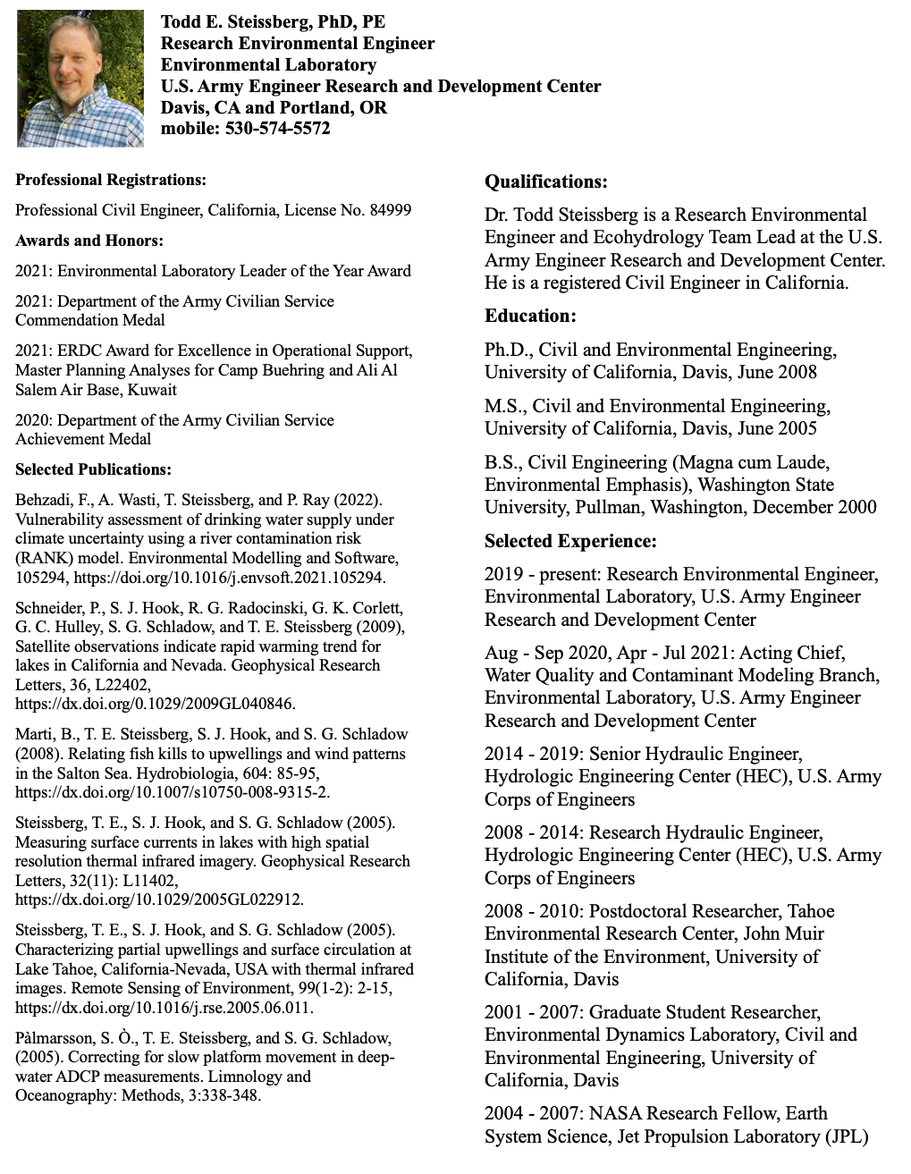

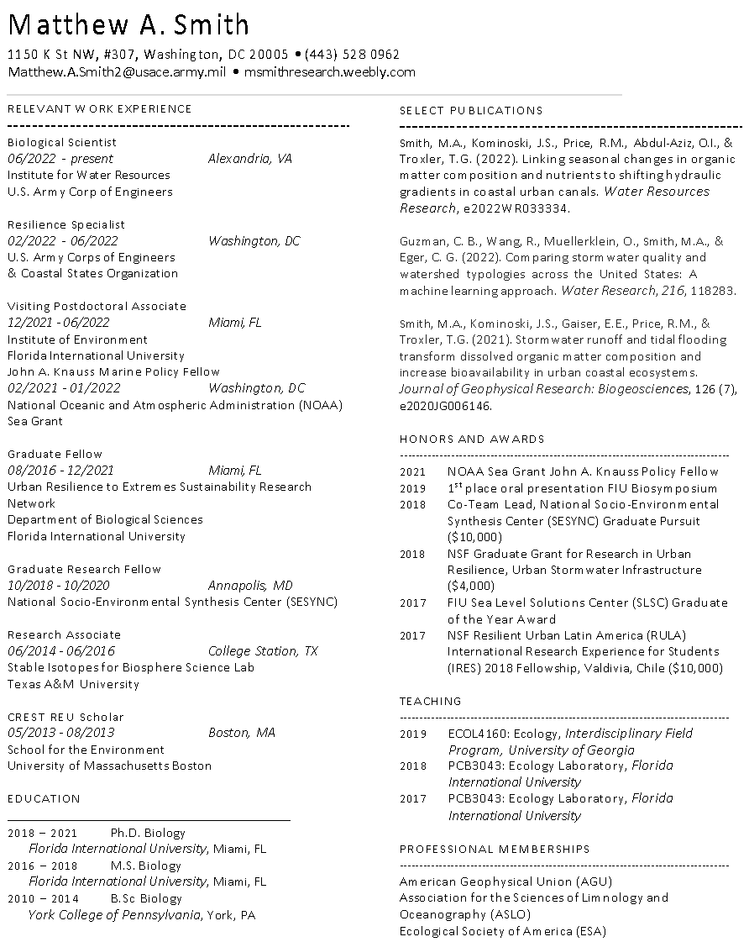

**4. Supporting Technical Data**

*Table 5. List of some of the monitored salt marsh restoration sites in the San Francisco Bay (Williams and Faber 2004). The WRMP has an updated list with all restorations and their descriptions / data collected up to today.*

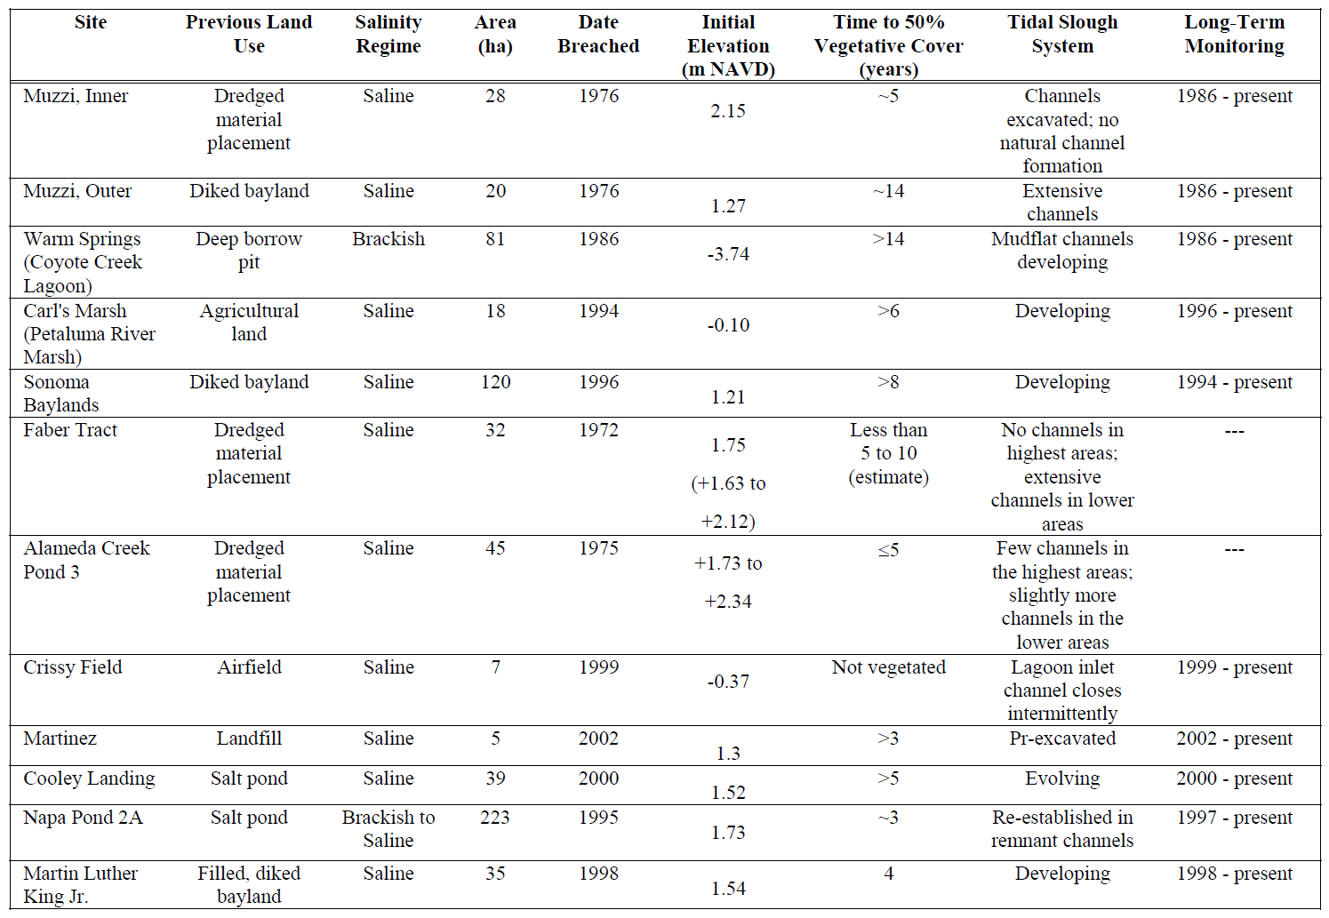

*Table 6. Key design objectives, indicators, and questions laid out in the “Design Guidelines for Tidal Wetland Restoration in San Francisco Bay” by Phillip and Faber (2004).*

|  |  |  |
| --- | --- | --- |
|  |  |  |
| **Objectives** | **Indicators** | **Design Questions** |
| 1. Allow for evolution of  biologically rich and diverse tidal wetland habitats. | Rate of species establishment and the diversity of species,  Area of vegetation | How will a restored site become vegetated marsh?  Q1-5, 10, 11 |
| 2. Promote the evolution of a complex tidal drainage system, particularly to support invertebrates, fish  and birds. | Drainage density,  Length and number of high order channels,  Sinuosity | How do we achieve a complex tidal drainage system?  Q1-7 |
| 3. Maximize the contribution of  the marsh to the estuarine ecosystem. | The extent of tidal exchange,  Connectivity with estuary and uplands | How do we connect the restored marsh to the estuarine ecosystem?  Q5 |
| 4. Create transitional wetland- upland habitat along the upland fringe. | Lineal extent, Composition and structure | How much transitional wetland-upland habitat do we create?  Q5, 9, 11 |
| 5. Provide appropriate habitat to support endangered species. | Stable populations of target species | What habitat supports target species? Q9, 12 |
| 6. Provide and enhance public access. | Extent of public access corridors, Accessibility of utility corridors | Q5, 13 |
| 7. Reduce flood hazards. | Flood damage potential, Water levels,  Reliability of levees | Q4, 5, 9, 14 |
| **Constraints** |  |  |
| 1. Potential impact on offsite flood hazards and drainage. | See above | See above |
| 2. Presence of public access or utility corridors. | See above | See above |
| 3. Prevention of colonization or intrusion by invasive species. | Presence of invasive species in the site and the vicinity | See EIR/EIS Guidance (CSCC and USFWS 2003)  Q4, 13 |
| 4. Requirements for mosquito control. | Extent of poorly drained wetland with emergent vegetation | Q2, 6, 7 |
| 5. Mitigation for conversion of existing seasonal wetland  habitat to tidal wetland. | Area of suitable shorebird habitat | Q8 |

Design Questions:

1.    Should the site be filled?

2.    Should fill be removed?

3.    Should a levee breach and outboard channel be excavated?

4.    Should wave breaks be constructed?

5.    Should the bayfront levee be lowered?

6.    Should new tidal channels be excavated?

7.    Should the pre-existing drainage system be modified?

8.    Should the site be graded to encourage panne formation?

9.    How should the wetland-upland transition be designed?

10. Should the soil be treated?

11. Should plants be planted?

12. How do we provide habitat features for target species?

13. How should public access be provided?

14. How should we integrate flood management issues?